Apache2

1. Apt-get isntall apache2

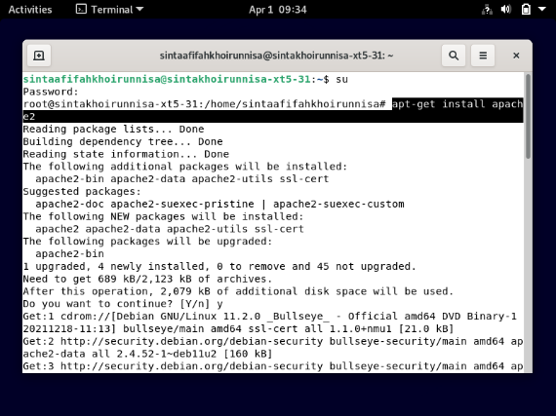

1. Systemctl status apache2

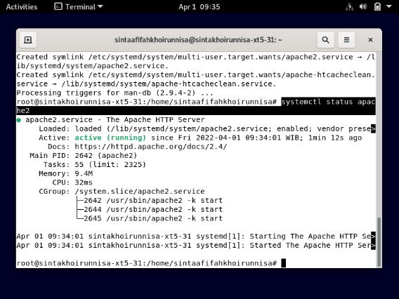

1. Ss firefox

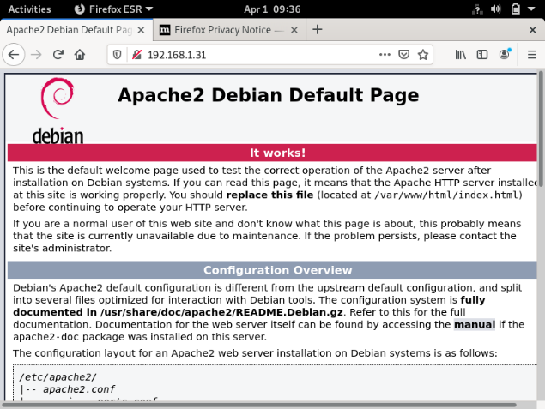

1. Host only (tdk usah)
2. Systemctl restart networking

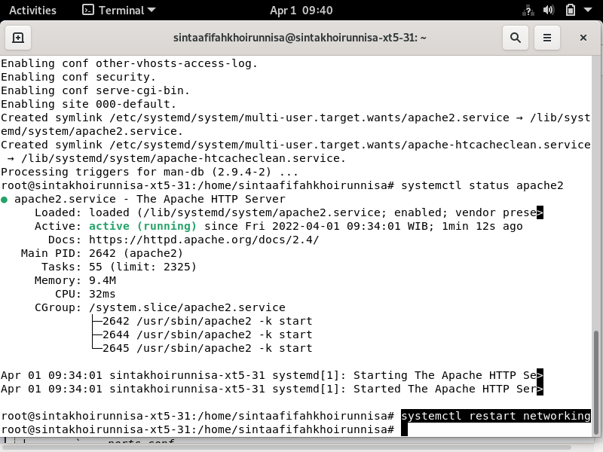

Bi9

1. bridge adapter
2. Apt-get install bind9

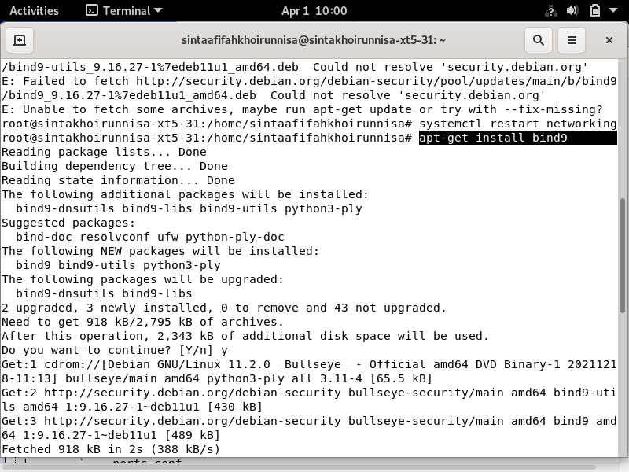

1. Systemctl status bind9

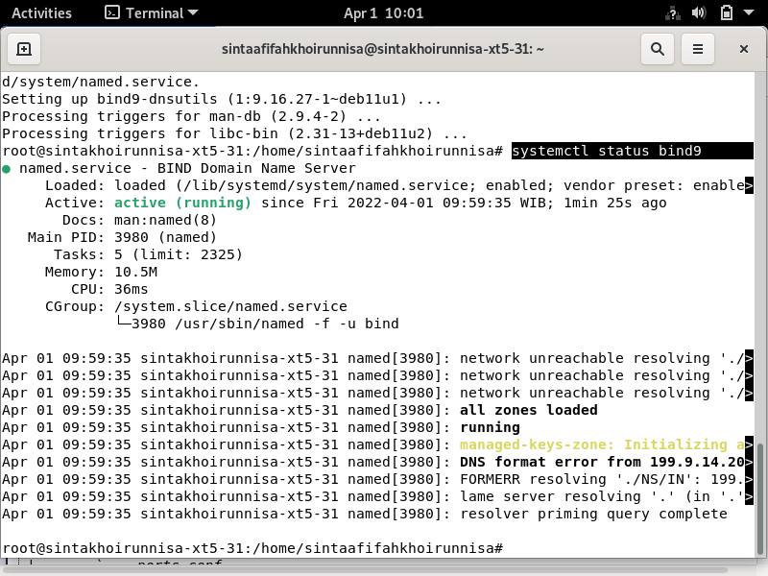

1. Ss fire fox

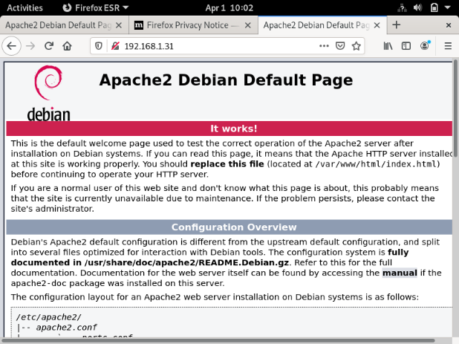

Konfigurasi virtual house (bridge adapter)

1. Cd /
2. cd /var/www/html + ls

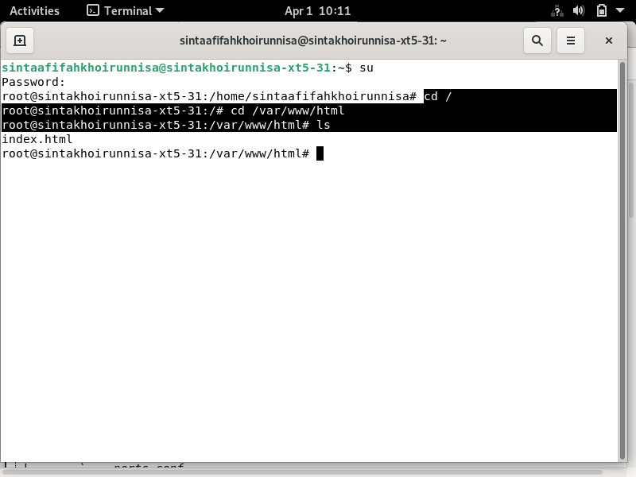

1. mkdir sintaT531 + ls

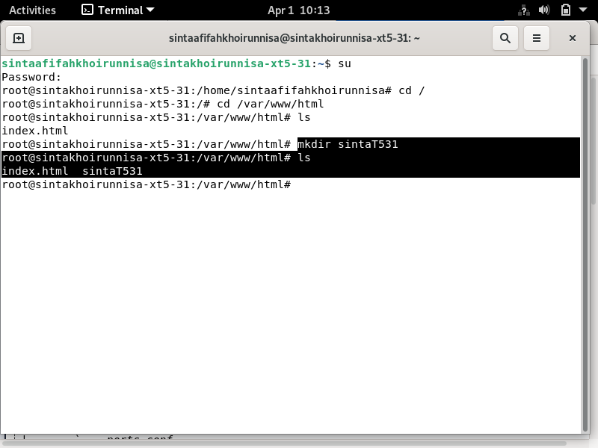

1. cd sintaT531

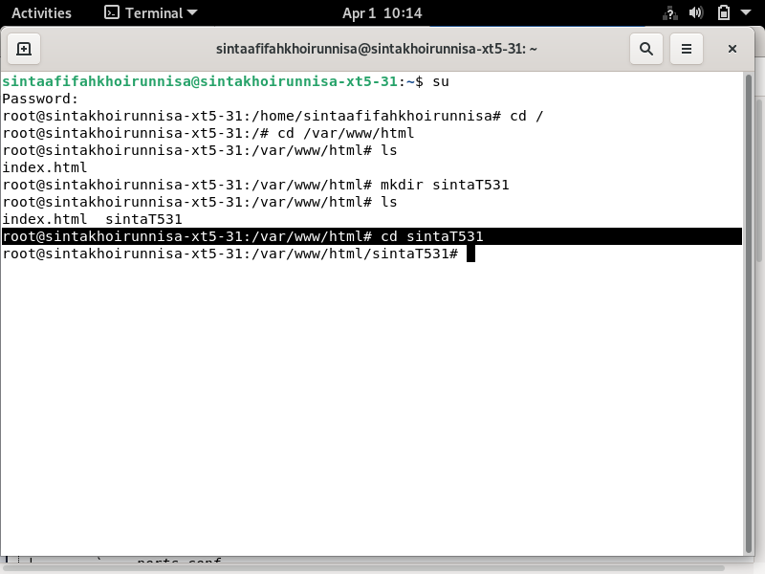

1. nano index.html

<!DOCTYPE html>

<html>

<body>

<h1>Sinta Afifah K</h1>

</body>

</html>

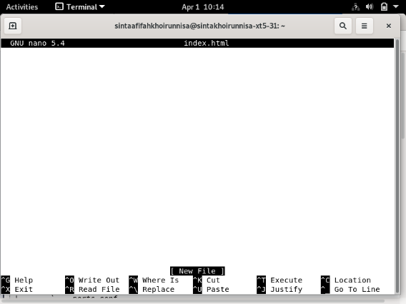 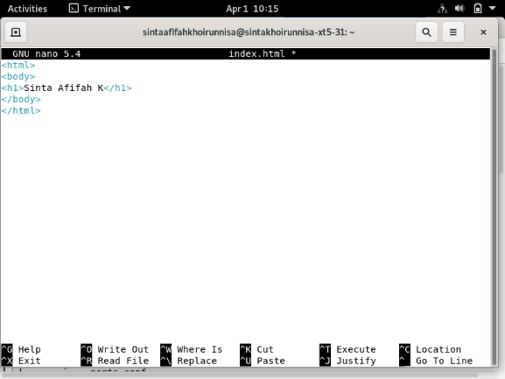

1. firefox : 192.168.1.31/sintaT531/

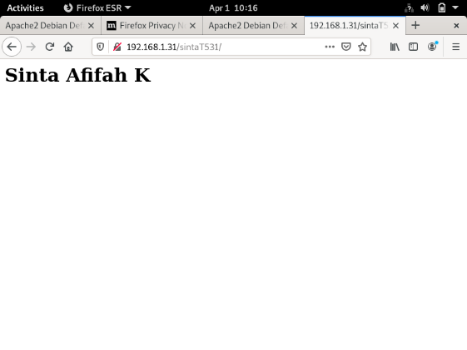

Agar saat searh di firefox Cuma 192.168.1.31 tanpa sintaT531

1. cd /
2. cd /etc/apache2/ + ls

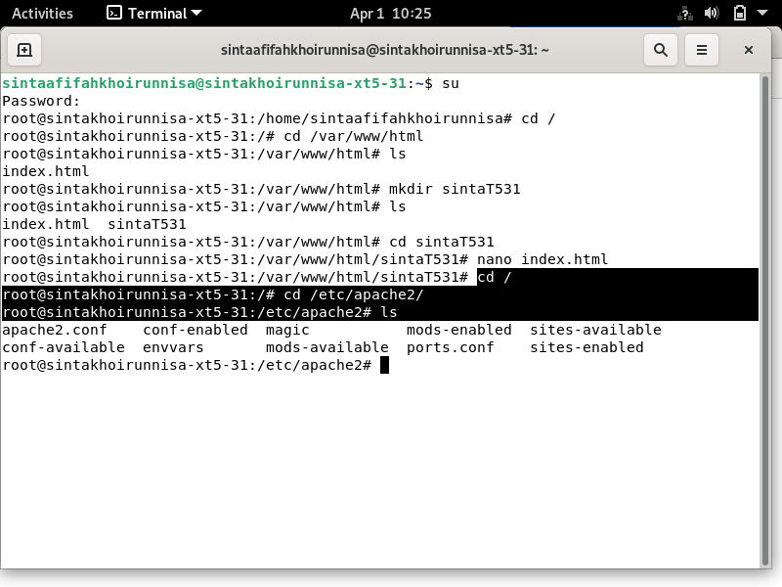

1. cd sites-available/ +ls

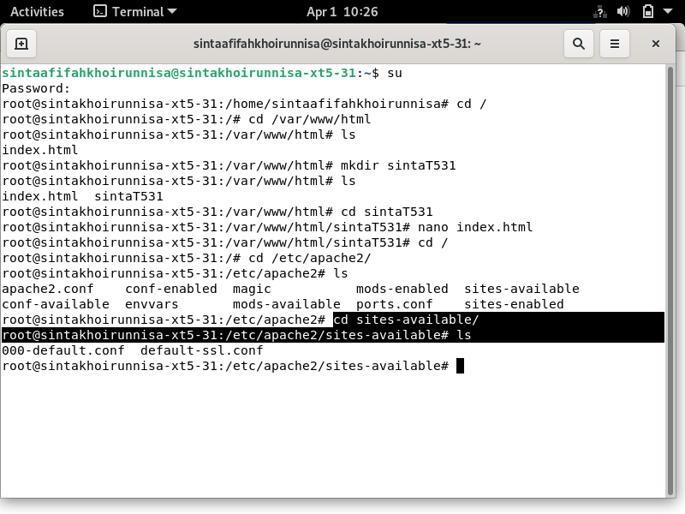

rm sintaT531 + ls (tdk jadi)

1. cp 000-default.conf sintat5.conf (file baru) + ls

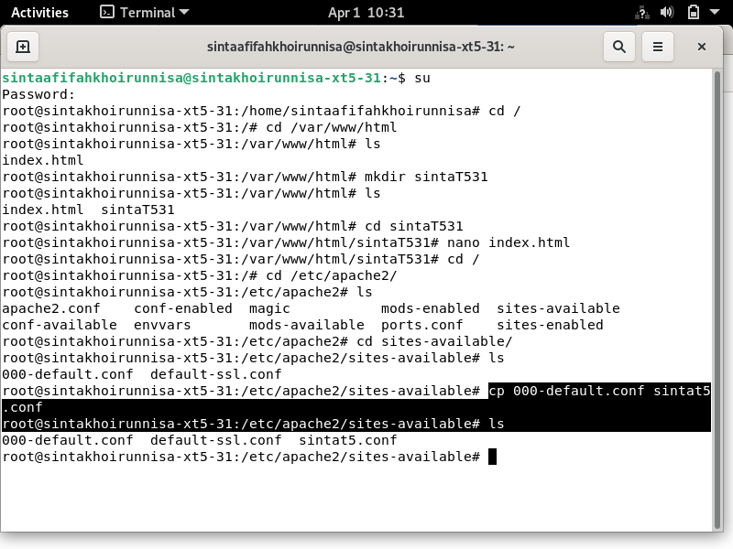

1. nano sintat5.conf

localhost : sintaa.com

html/sintaT531 (nama file awal)

[www.sintaa.com](http://www.sintaa.com)

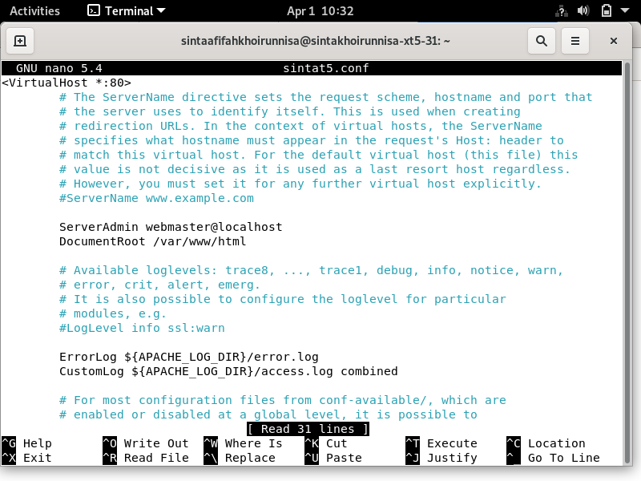 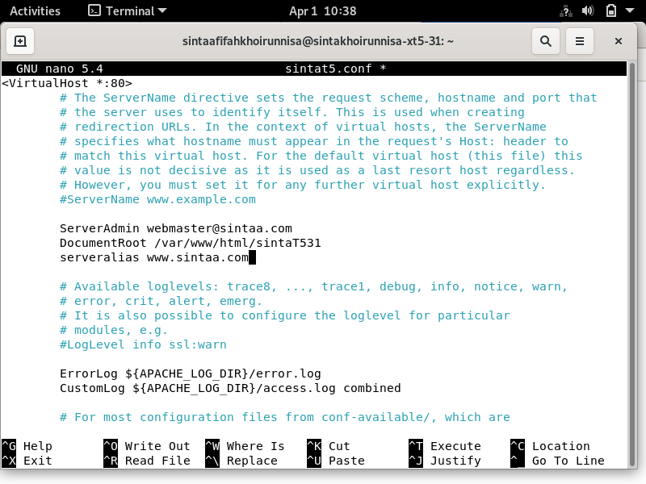

#memasukkan sintat5 ke sites enable

1. cp sintat5.conf /etc/apache2/sites-enabled/

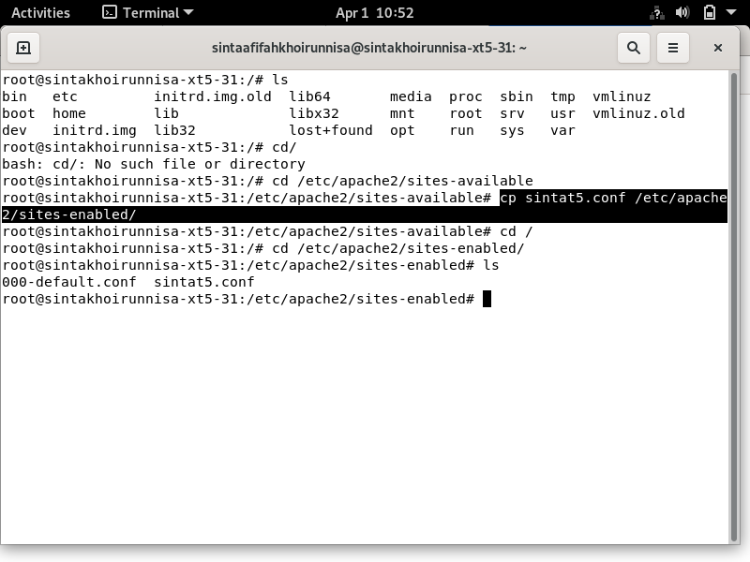

1. cd /
2. cd /etc/apache2/sites-enabled/ + ls

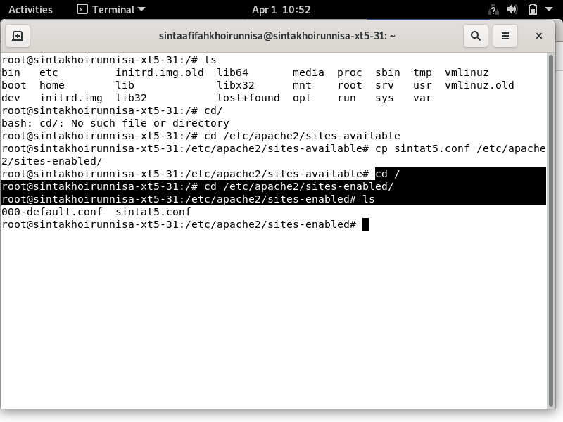

1. rm 000-default.conf

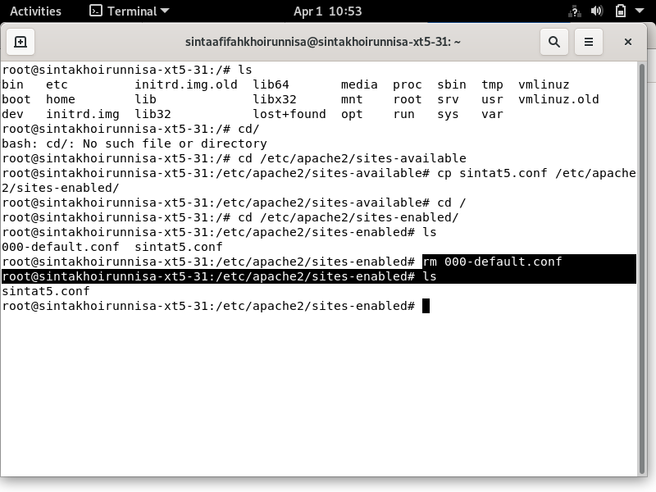

1. systemctl restart apache2

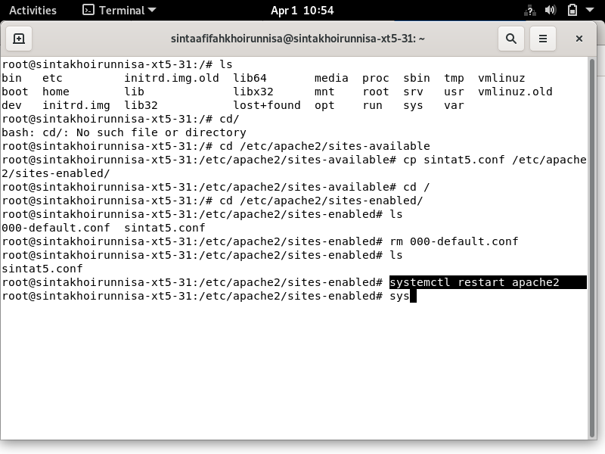

1. systemctl status apache2

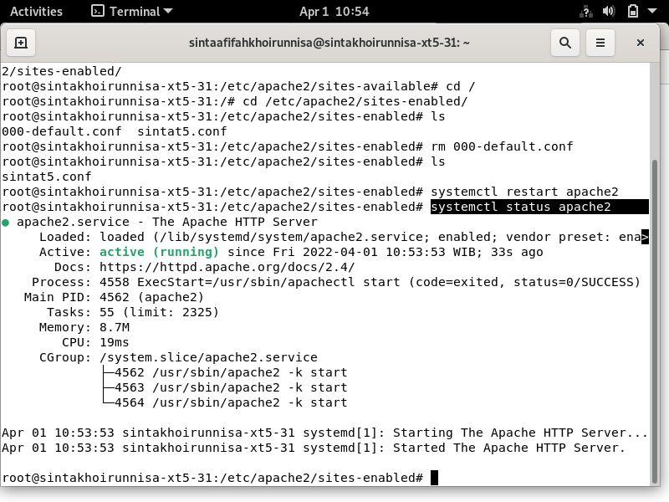

1. firefox: 192.168.1.31

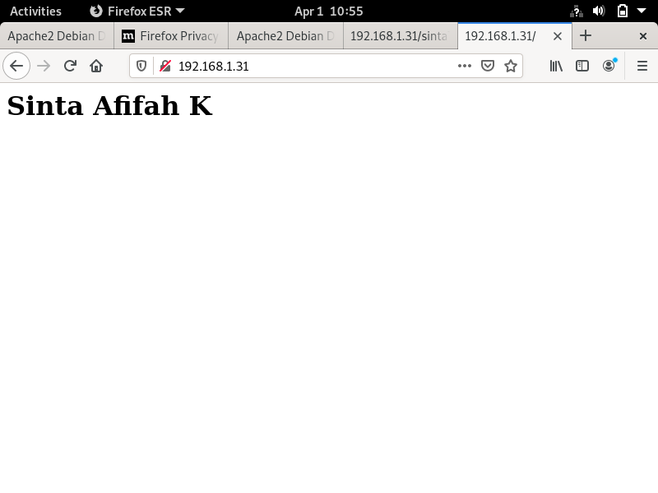

Konfigurasi dns

1. cd /
2. cd /etc/bind/ + ls

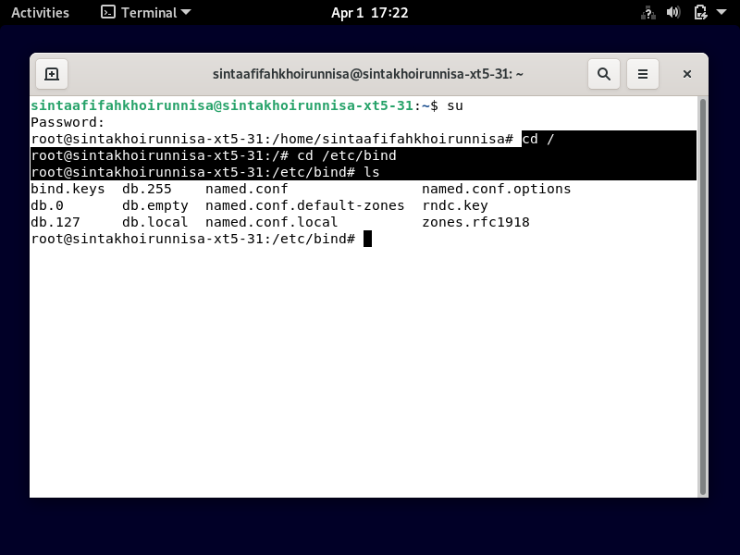

1. cp db.local db.31sinta + ls

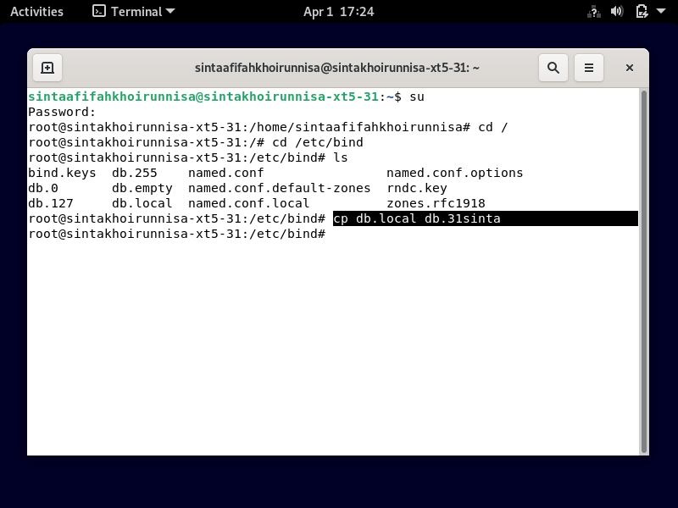

1. cp db.127 db.31 (oktet4)

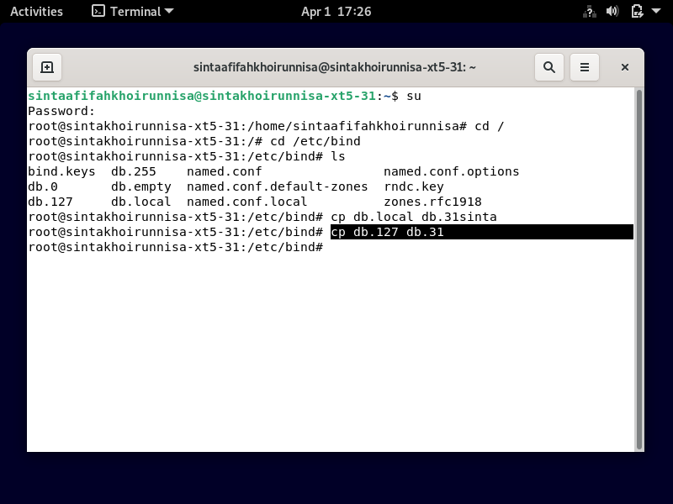

1. nano named.conf.default-zones

zone “sintaa.com”

type master;

file “/etc/bind/db.sintaa”

zone “192.in-addr.arpa” {

type master;

file “/etc/bind/db.31”;

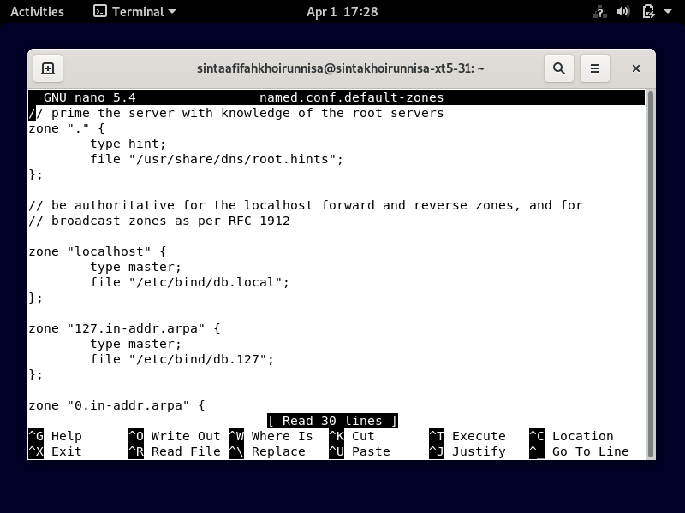 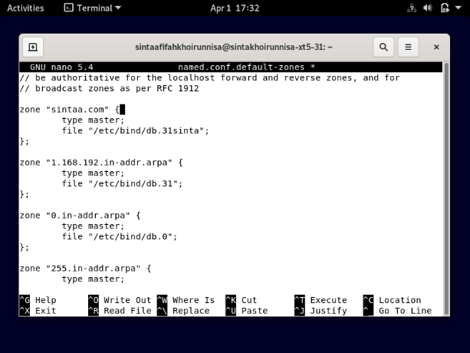

1. nano db.31sinta

local host : sintaa.com (namadomain)

masukkan ip Debian di bawah .­­­

triple A : hilangkan

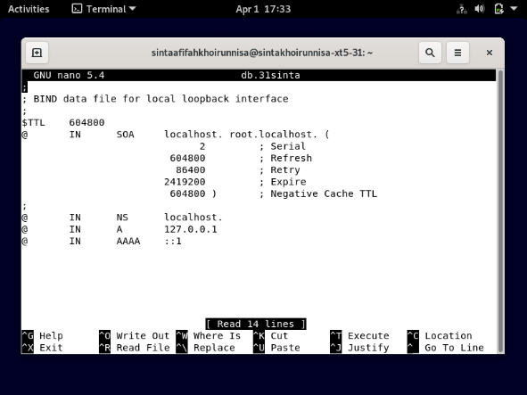 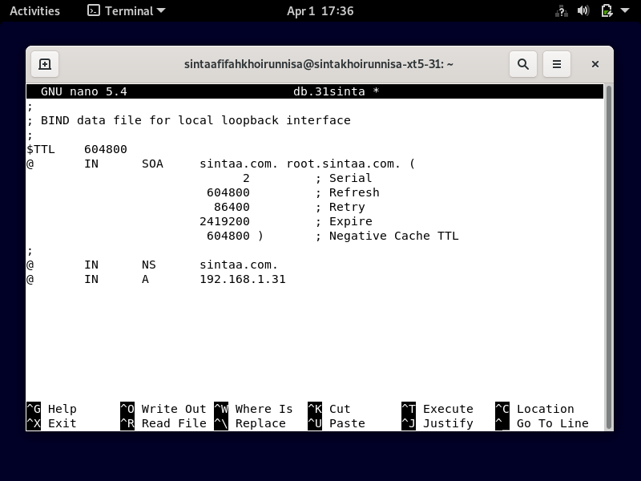

1. nano db.31 (oktet4)

local host :sintaa.com (domain)

octet dibalik 4-3-2 : 31-1-168

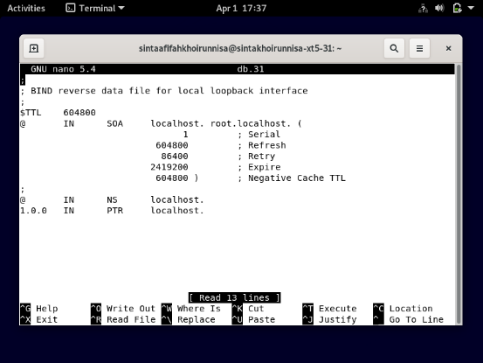 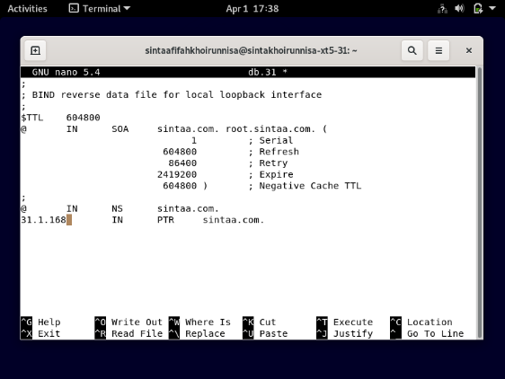

1. nano named.conf.options

forwarders hapus 3 kebawah

bawah forwarders diganti ip Debian

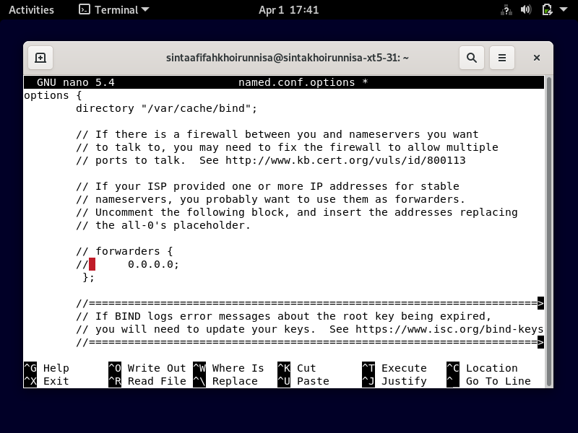 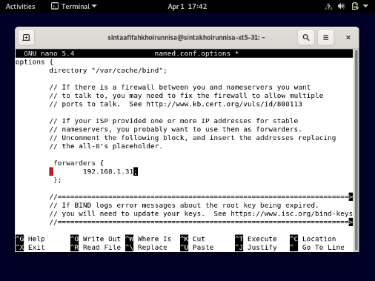

1. nano /etc/resolv.conf

search sintaa.com

nameserver 192.168.1.31

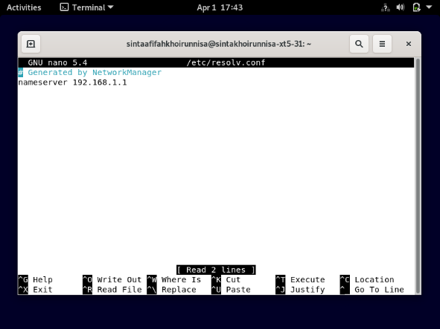 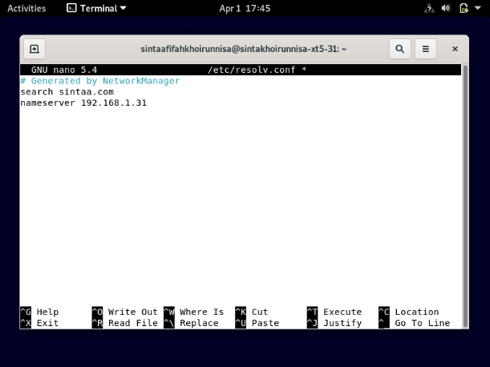

1. systemctl restart bind9

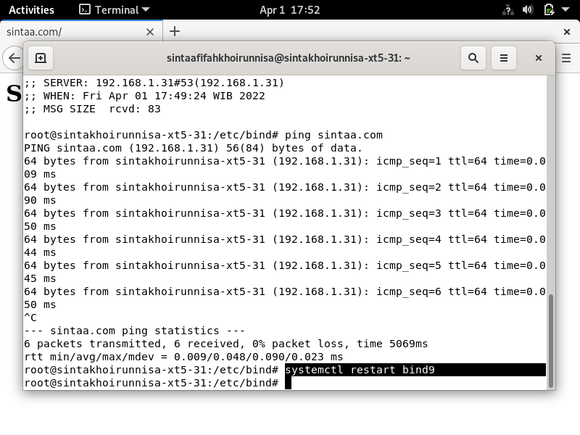

1. systemctl status bind9

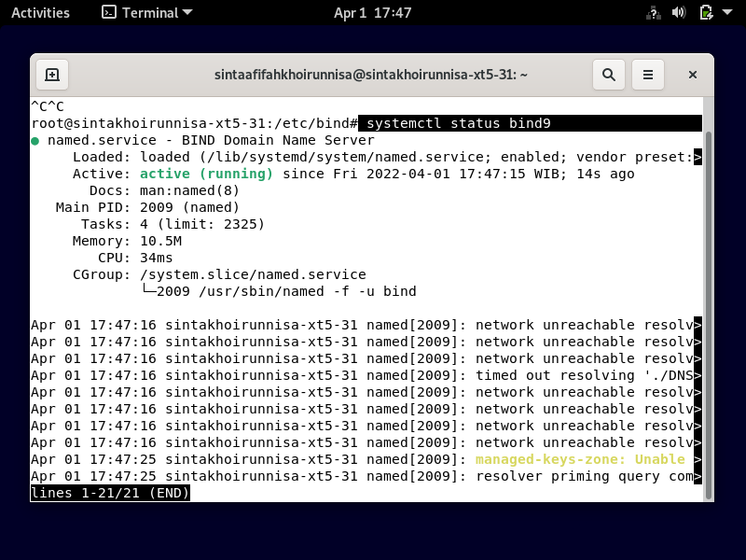

1. nslookup

masukkan domain : sintaa.com

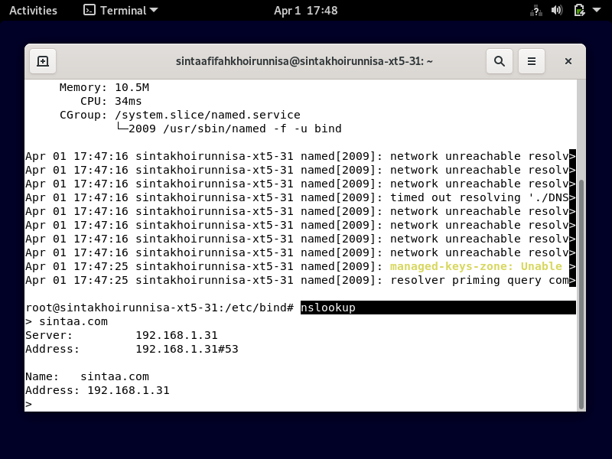

1. dig sintaa.com

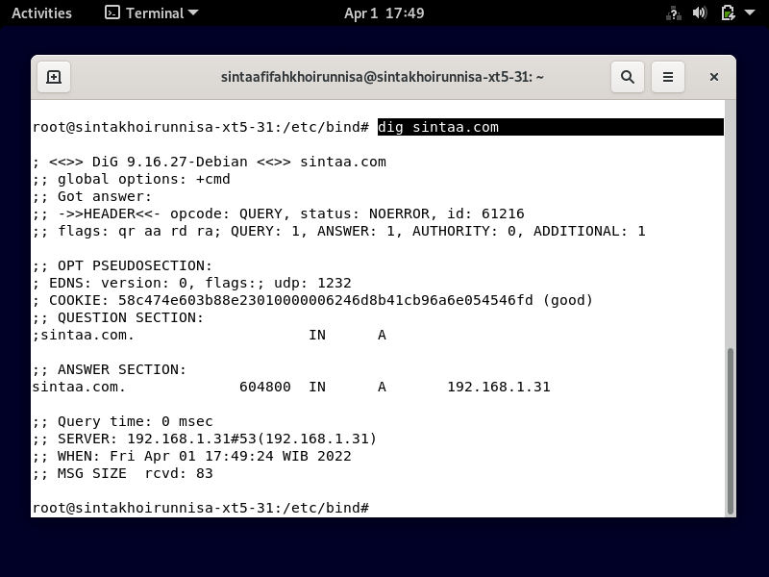

1. ping sintaa.com

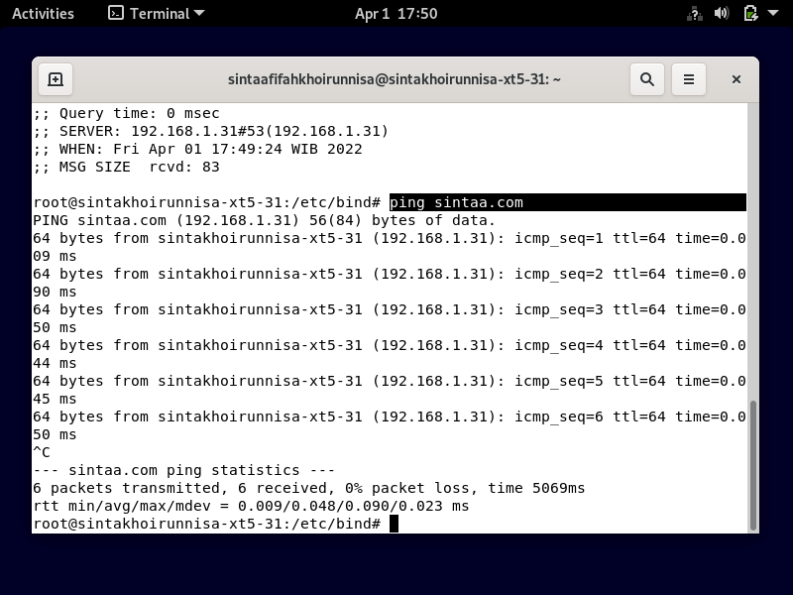

1. firefox : sintaa.com

